Der Dekan der Philologisch-Kulturwissenschaftlichen Fakultät, das Institut für Ostasienwissenschaften – Japanologie der Universität Wien und der Akademische Arbeitskreis Japan
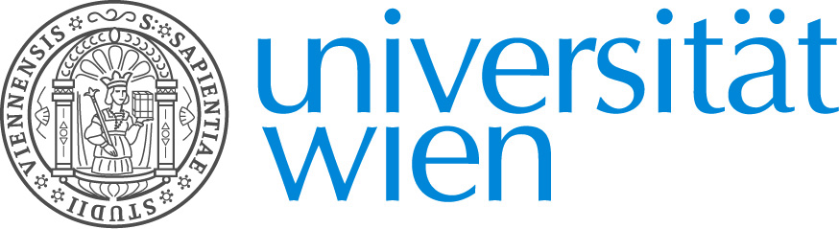
laden ein zu einem

VORTRAG
Donnerstag, 12. November 2015, 18:30

Robert Hellyer
(Wake Forest University)

From Green to Black:
How Black Tea Conquered Britain and the United States & Sencha Japan
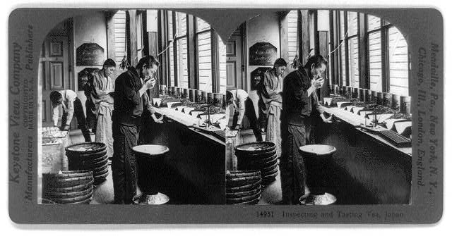
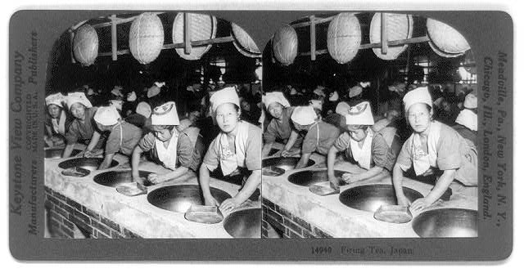

The presentation will explain how marketing, as well as national/imperial trade agendas and racial stereotypes, helped shape tea consumption patterns in Britain, the United States and Japan since the mid-nineteenth century. It will show how rising concerns about the “dangers” of Chinese green tea spurred British consumption of black teas, while an influx of inexpensive Japanese greens bolstered US green tea consumption from the 1870s. Beginning in the 1890s, British firms mounted a marketing campaign, again stressing the “dangers” of green tea, which in a few decades helped India and Ceylon black teas come to dominate the US market. Facing a glut because of shrinking US demand, Japanese producers shifted attention to domestic and imperial markets, promoting the sale of previously exported sencha green tea, especially for its purported high content of Vitamin C.

Robert Hellyer is Associate Professor of History at Wake Forest University (USA). A historian of early modern and modern Japan, Robert Hellyer served on the faculty of the University of Tokyo, taught at Allegheny College and was a postdoctoral fellow at the Reischauer Institute of Japanese Studies at Harvard before coming to Wake Forest in 2005. His research includes Edo period foreign relations (Defining Engagement: Japan and Global Contexts, 1640-1868, Harvard University Asia Center, 2009), socio-economic integration of the Pacific Ocean in the 18th and 19th centuries and Japan’s Meiji Restoration. For his current project on the international history of Japan’s export of green tea to the United States from circa 1850 to 1950 he received Smithsonian, Japan Foundation, and National Endowment for the Humanities fellowships. In the fall semester 2015, he is serving as resident professor at Wake Forest’s Flow House in Vienna.

Institut für Ostasienwissenschaften – Japanologie, Seminarraum 1

